AIM
To implement Support Vector Machine (SVM) for classification and improve model performance using hyperparameter tuning.
THEORY
Support Vector Machine (SVM) is a supervised machine learning algorithm used for classification tasks. It works by finding the optimal hyperplane that separates data points of different classes with maximum margin.
Key concepts:
- Hyperplane: Decision boundary separating classes
- Support Vectors: Data points closest to the boundary
- Margin: Distance between classes and hyperplane
Kernel Functions:
- Linear
- Polynomial
- Radial Basis Function (RBF)

Hyperparameter Tuning
Hyperparameters control model performance:
- C → controls regularization (overfitting vs underfitting)
- Kernel → type of decision boundary
- Gamma → influence of data points
Tuning helps find the best combination for maximum accuracy.
PROCEDURE
- Load dataset using pandas
- Separate features and target
- Convert categorical labels into numeric
- Split dataset into training and testing sets
- Apply feature scaling
- Train SVM model
- Perform hyperparameter tuning using GridSearchCV
- Predict results
- Evaluate using confusion matrix and accuracy
CODE:
# ====================================================
# SUPPORT VECTOR MACHINE (SVM) - dat.csv DATASET
# ====================================================

# -------- IMPORT LIBRARIES --------
import pandas as pd

from sklearn.model_selection import train_test_split, GridSearchCV
from sklearn.preprocessing import StandardScaler, LabelEncoder
from sklearn.svm import SVC
from sklearn.metrics import confusion_matrix, accuracy_score, classification_report

# -------- LOAD DATASET --------
data = pd.read_csv("data.csv")

print("Dataset Preview:\n")
print(data.head())

# -------- FEATURES & TARGET --------
# Assuming last column is target
X = data.iloc[:, :-1]
y = data.iloc[:, -1]

# Convert target to numeric (if needed)
le = LabelEncoder()
y = le.fit_transform(y)

# -------- TRAIN TEST SPLIT --------
X_train, X_test, y_train, y_test = train_test_split(
X, y, test_size=0.2, random_state=42
)

# -------- FEATURE SCALING --------
scaler = StandardScaler()
X_train = scaler.fit_transform(X_train)
X_test = scaler.transform(X_test)

# -------- SVM MODEL --------
svm_model = SVC()

# -------- HYPERPARAMETER TUNING --------
param_grid = {
'C': [0.1, 1, 10],
'kernel': ['linear', 'rbf'],
'gamma': ['scale', 'auto']
}

grid = GridSearchCV(svm_model, param_grid, cv=5)
grid.fit(X_train, y_train)

# -------- BEST MODEL --------
best_model = grid.best_estimator_

print("\nBest Parameters:", grid.best_params_)

# -------- PREDICTION --------
y_pred = best_model.predict(X_test)

# -------- CONFUSION MATRIX --------
conf_matrix = confusion_matrix(y_test, y_pred)

conf_df = pd.DataFrame(conf_matrix)

print("\n===== CONFUSION MATRIX =====")
print(conf_df)

# -------- PERFORMANCE --------
accuracy = accuracy_score(y_test, y_pred)

print("\nAccuracy:", accuracy)

print("\n===== CLASSIFICATION REPORT =====")
print(classification_report(y_test, y_pred))

OUTPUT:

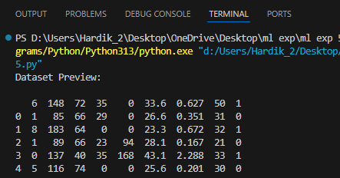

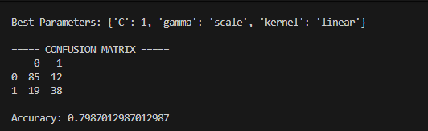

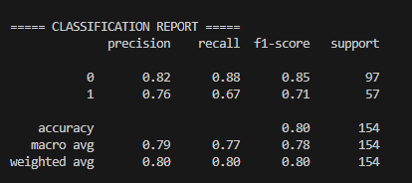
CONCLUSION
Support Vector Machine successfully classified the dataset with high accuracy. Hyperparameter tuning improved the model performance by selecting the best values for C, kernel, and gamma. The SVM model achieved better accuracy compared to basic models due to optimal decision boundaries. It is highly effective for classification problems, especially with proper tuning

